GUIA DE AUTOAPRENDIZAJE Nº12 INGLÉS
I° MEDIO
UNIT 2: KEEP ON LEARNING
ANSWERS

Class: https://youtu.be/v_BuIpuTufk

Al final de esta guía se espera que el estudiante desarrolle los objetivos de aprendizaje relacionados con:

- Aplicar vocabulario temático de la unidad.
- Reforzar el uso de comparativos y superlativos.
(OA1-0A14)

- Student’s book: (page 62) Use the name of the elements of a piece of news in the box to match each definition (a - g)
Body Byline End Headline Lead Quotations Visuals

a. HEADLINE: It catches your eye and sums up the story. It is usually in larger font and
often in bold.
b. BYLINE: This tells who wrote the article and sometimes the journalist’s specialty.
c. LEAD : This gives the most important information very brief.
d. BODY: It supplies additional information. It is divided into small paragraphs.
e. QUOTATIONS: These retell, word for word, what someone actually said.
f. VISUALS: These are images used to make a text easier to understand or more interesting.
g. END: It expresses general conclusions about the topic.

II. Identify and label the different parts of this piece of news. (Page 63)

a. HEADLINE
b. LEAD
c. BYLINE
d. BODY
e. END

III. Complete the following sentences. Use the comparative form of one of these adjectives. Use each word only once. Add 'than' if necessary.

good fat high difficult lazy old

1. My exam results are good. They are BETTER THAN last year.
2. Mount Everest is HIGHER THAN Mont Blanc.
3. I am eating too much. I am much FATTER THAN I was last month.
4. This exercise is very easy. Can you give me something MORE DIFFICULT?
5. My mother is 42 but my father is much OLDER. He's 55.
6. Robert is LAZIER THAN anyone I know. He never lifts a finger to work.

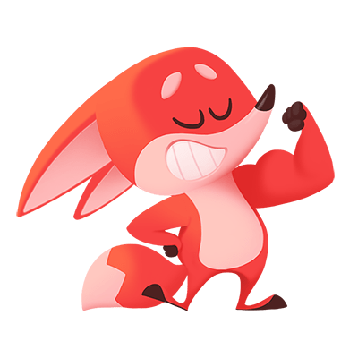
Nota:
Espero las respuestas correctas te hayan servido!
Trabaja con tu texto escolar y revisa cada pregunta detenidamente.
Si al final de la guía lograste 2 items correctos, felicitaciones! Si solo lograste 1 ítem correcto, tu puedes!
Estas a punto de alcanzar el objetivo! Pone atención en los errores para la próxima y revisa el link de la clase en: https://youtu.be/v_BuIpuTufk
You can do it!

