GUIA DE AUTOAPRENDIZAJE Nº13 INGLÉS
IIIº MEDIO

Nombre_______________________________________ Curso:_______ Fecha: _______
En esta guía el estudiante estará practicando las habilidades que el idioma inglés requiere para mantener una continuidad en su proceso de aprendizaje.

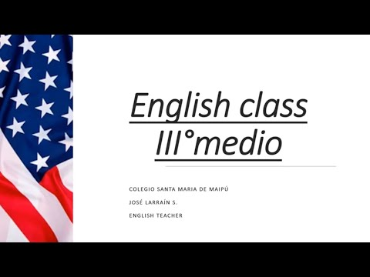
I.- WATCH THE FOLLOWING VIDEO AND USE YOUR NOTEBOOK WHEN YOU ARE TOLD TO. (CLICK ON THE IMAGE BELOW AND THE VIDEO WILL PLAY AUTOMATICALLY)
- DON’T FORGET TO COMPLETE THE ACTIVITIES PROVIDED ON THE VIDEO ABOVE, USE YOUR NOTEBOOK TO KEEP RECORDS OF THEM.
Highlighted words | Sentences.
Has improved | Technology has improved the lives of many people.
II.- COMPLETE THE FOLLOWING CHART WITH THE MISSING INFORMATIOMN FROM THE VIDEO ABOVE.

.

III.-LISTEN AND ANSWER THE FOLLOWING QUESTIONS.

1.- The people are __________ right now.
a.- at a park
b.- in a hotel
c.- at the airport

2.- Sara is the man's _______.
a.- mother
b.- spouse
c.- sister

3.- The man has _____ dollars on him.
a.- ten
b.- fifteen
c.- five

4.- He lost ________ at the casino last time.
a.- $1,700
b.- $1,500
c.- $1,200

5.- The man and woman are probably going to _______ at the end of the conversation.
a.- go sightseeing in town
b.- shop for new clothing
c.- buy food for their friends

*note: you can find out the right answers in the link provided in the instructions.

CONTACT INFO: ING.TERCEROMEDIO.SMM@GMAIL.COM

